Career Planning - working document
Wonderful that you are making a start with your preparation for the job market. As a student at Leiden University, you can visit the Leiden University Career Zone. This Career Planning working document is part of the Career Planning Roadmap for the Career Zone.
In this roadmap, you are asked to complete one or more assignments at each step. The results of most of these assignments can be logged in this document. You will complete a number of assignments in other documents. Save all documents in a Career Planning folder on your computer, so that you can keep everything together. With the assembly of all these documents you will eventually have your Career Planning portfolio. You can run through this module and perform assignments when you are working on career orientation with your mentor or tutor group, but you can also complete it independently. There is a logical structure in the assignments, but if desired, the modules can also be used independently.
1. In Career Orientation Process you will find assignments regarding:
  - Career Orientation Process
  - Employability
  - Career stress
  - Study career planning

2. In Step 1. Know yourself you will find assignments related to your Personal profile:
  - Competencies
  - Personality
  - Career choice
  - Work values
  - Team roles
3. In Step 2. Explore the labour market you will find assignments regarding personal career profile:
  - Personal career profile
  - Types of work
  - Types of organizations
  - People
  - Working conditions
  - Networking
  - Personal career profile 2
4. In Step 3. Develop your (job application) skills you will find assignments related to:
  - Curriculum Vitae
  - LinkedIn profile
  - Cover letter
  - Pitch
  - Job interview
  - Assessments
  - Working conditions
5. In Step 4. Find a job (vacancy) you will find assignments related to:
  - Networking
  - Finding a vacancy (and applying for a job)
  - Recruitment
6. In Transition to the labour market, attention is paid to the transition to a new phase in your life and your preparations for your first job.
7. In Completing Career Planning module you will find an assignment for a:
7.1 Action plan
7.2 Career Pitch

1. CAREER ORIENTATION PROCESS

1.1 Career orientation process
The career orientation process consists of much more than just job searching. It is a process that consists of a number of steps in which you get to know yourself and the labour market better. Even if you only just started your studies, the career orientation process is interesting to delve into. If you pay close attention to the different steps, the transition to the labour market and finding a suitable job will eventually become easier.
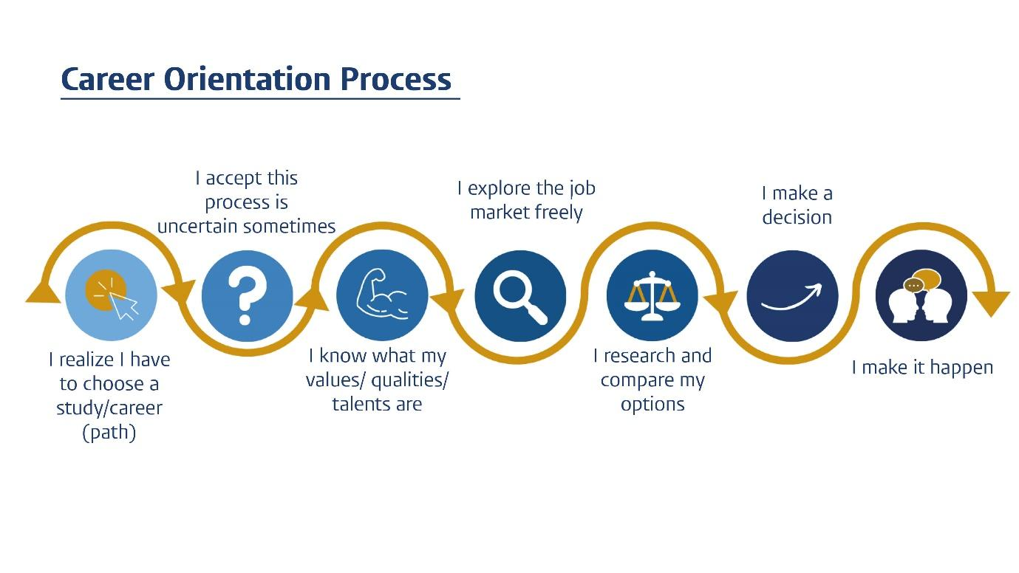
Learning objective of this submodule:
- At the end of this submodule you will be able to give a short introduction of yourself;
- You will be able to formulate your motivation for choosing your study programme;
- You will be able to express your expectations for the study programme.
Assignment:
- Describe in a few sentences your motivation for choosing your study programme (Bachelor or Master):

- What do you expect from this study programme? What do you think you will learn / develop?

- Do you already have an idea about a specialization/subject that interests you?

- Bachelor student: which masters / specializations are of interest and why?

- Master student: o you have an idea about an interesting niche area/ positions? Please, explain.

- What are you proud of? (e.g. an activity you have done in your life - small / big / can be anything.)

Go through the steps of the career orientation process.

- Describe (in the working document) at which step (s) you are in this process and why?

- What do you want to work on in the coming academic year and why?

1.2 Employability
When going through the career orientation process, it helps to recognize your "Employability". But what exactly is that? And what are Employability skills? Employability skills are key skills that you require in any job, such as creativity, communication, presentation and planning. These are skills that employers ask for and are at least as important as job-specific or practical skills. The more of these skills you can master, the more employable you will be, the higher your chances of obtaining a job and career advancement.
Learning objective of this submodule:
- You know what employability and employability skills imply;
- You can name a couple of your employability skills;
- You can formulate which skills you would like to develop and how you can formalize this;
- You are able to give tips to the other in the field of developing these skills.

Assignment:
In ‘Step 1, Know yourself’, you will look more specifically and elaborately at your competencies with the help of a competency test. In this assignment you will already start reflecting on your competencies based on the information you have just read. Describe your thoughts below.
- Name three competencies (each with a description) that you are (already) good at and in which position(s) you could use them.

Competency 1:
Position(s):

Competency 2:
Position(s):

Competency 3:
Position(s):

- And which competencies would you like to develop further? And where could you do that (think of opportunities within and outside the curriculum)?
Competency 1:
Situation/location to develop:

Competency 2:
Situation/location to develop:

Competency 3:
Situation/location to develop:

- Look at the course descriptions in the e-prospectus:
Which employability skills do you recognize in your study programme?

Employability skills in my study programme:

1.

2.

3.

4.

1.3 Career stress
Looking for a job or shaping your study career can cause (some) tension. It is good to know that you are not alone in this. It may help to visualize your obstacles in order to learn to deal with them better, so that you can bring peace back to your search process.
Learning objective of this submodule:
- You have identified what makes you insecure with regard to preparation for the labour market and the shaping of your study career (such as choice stress, perfectionism, social comparison, being meaningful, uncertainty of the labour market, etc.).
- You realize that this (unsecure) stage is part of the study career process.
- You learn to develop a roadmap to transform these thoughts.
Assignment:
- What issues or internal conflict do you have that (sometimes) block you from freely investigating what personal career profile fits you best.
- What thoughts do you have when you experience career stress?
- Think about situations when you do not have this stress reaction and actually feel content. What's different in that situation?
- What positive thoughts do you have then?
- What actions could you take to keep your positive thoughts?
Obstacle / stressor:
1. Name one thought associated with career stress:

2. When do you not have this thought? What's different in that situation?

3. What positive thoughts do you have?

4. What actions can you take to maintain these positive thoughts??

Obstacle / stressor:
1. Name one thought associated with career stress:

2. When do you not have this thought? What's different in that situation?

3. What positive thoughts do you have?

4. What actions can you take to maintain these positive thoughts??

Obstacle / stressor:
1. Name one thought associated with career stress:

2. When do you not have this thought? What's different in that situation?

3. What positive thoughts do you have?

4. What actions can you take to maintain these positive thoughts??

1.4 Study Career Planning
During your studies (whether you are in your bachelor or in your master) it is good to be aware of the choices you make, the skills you develop / want to develop and the experience you are gaining / want to gain, in order to increase your employability and prepare you for your career after university.
Learning objective of this submodule:
- You are aware of the study career planning and the activities that can be linked to it each academic year;
- You are aware of the possibilities within and outside your curriculum, which can be part of your career preparation after graduation.
Assignment:
- Read the information about the Career Route Planner and study career planning.
- Have you chosen or made plans within your study programme for ( for example) an internship, a study subject/module for abroad, honours programme or otherwise? Motivate your choice (Yes or No, because…..).

Yes / No

Because:

- What have you already done in addition to your study programme? What have you learned from this experience/these experiences?

Activity 1:

What I have learned:

Name the skills that I have developed:

Activity 2:
What I have learned:

Name the skills that I have developed:

Activity 2:
What I have learned:

Name the skills that I have developed:

- What do you want to do? Do you already have an idea and what do you hope to learn from it?

Activity 1:
What I want to learn / develop:

Activity 2:
What I want to learn / develop:

Activity 3:
What I want to learn / develop:

Tip! Discuss your study career planning (your accumulated CV or new study/career plans) with a fellow student and give each other tips.

2. STEP 1. KNOW YOURSELF
The first step in the career orientation process is to know who you are; to gain insight in your own unique personal profile. You call this process self-analysis or self-assessment (Know yourself) and it forms the basis for making good choices and decisions in your life.
If you know who you are, what your capabilities are and what you want (characteristics, competencies, interests, values, etc.), you can better determine what suits you and this helps you to give direction and make decisions.
In this module you will make various tests and assignments to discover your:
- Competencies
- Personality
- Career choice
- Work values
- Team roles
Perceive the outcome of the test(s) primarily as an indication and not so much as a complete and definite profile: the results of these tests represent snapshots taken at a certain state of mind/moment in life. Use them mainly as a tool for reflection.

2.1 Competencies
Gaining insight into your competencies and ongoing development is of great importance for your career. You can take a Competency test on the Career zone. Read the report carefully so that it is clear how you should interpret the results. Also save your test results (pdf) in your Career Planning folder, for easy access. Then complete the assignment below.
Learning objective of this submodule:
- identifying your strengths and weaknesses;
- insight into situations in which you have applied your competencies;
- knowledge of the STAR-method and how to apply it.

Assignment:
- View your results (Do you recognize the outcome? What stands out?) and also view the development tips.
I recognize:

What else stands out:

- Write down your five strongest competencies in your Career Planning work document. For each competency, name an example of a situation where you have been able to use this competency. Also describe the result of your action.
My five strongest competencies are:
Competency 1:
Example of a situation:

Result:

Competency 2:
Example of a situation:

Result:

Competency 3:
Example of a situation:

Result:

Competency 4:
Example of a situation:

Result:

Competency 5:
Example of a situation:

Result:

- Name three weaker competencies that you would like to develop further (also take a look at the development tips in your test report). And describe how you will approach the development of these competencies.
Competency 1:
I can develop this competency by:

Competency 2:
I can develop this competency by:

Competency 3:
I can develop this competency by:

- Take a look at these competencies. These are skills that you are good at. However, it is also important that you get energy from the activity for which you use your competency. Take another look at your most important competencies in the test results: what are you not only good at, but also gives you energy?
Competencies I get energy from:

2.2 Personality
People's personality is determined by their personality traits and behaviour. The Personality test on the Career Zone gives you more insight into your personality. Read the report carefully so that it is clear how you should interpret the results. Also save your test results (pdf) in your Career Planning folder, for easy access. Then complete the assignment below.
Learning objective of this submodule:
- acknowledging what traits are dominant in your personality;
- knowledge of which pitfalls belong to those personality traits.

Assignment:

- View your results. Do you recognize the outcome? What stands out?

- Ask family and friends if they recognize the results from the report. What personality traits do they see in you?

- Write down the three greatest insights about yourself and the impression that others have about you.
My own insights:
1.
2.
3.

Insights gained through the image that others have of me:
1.
2.
3.

2.3 Career choice (Interests)
In order to properly determine where your interests and ambitions really lie, it is advisable to take a career test. The career test at the Career Zone examines to what extent the following characteristics apply to you: Social (So), Conventional (Co), Artistic (Ar), Entrepreneurial (En), Investigative (In) and Realistic (Re). Everyone possesses these characteristics to some extent, but the characteristic(s) that is (are) the most dominant, determine(s) your professional personality. After completing the test, you will get a summary of personality profiles and corresponding professions.
Take the Career test on the LU Career Zone. Read the report carefully so that it is clear how you should interpret the results. Also save your test results (pdf) in your Career Planning folder, for easy access. Then complete the assignment below.
Learning objective of this submodule:
- gaining insight in your personality profile;
- knowledge of which professions best fit your personality profile
Assignments:
- Write down the outcome of the Career choice test:
Write down from the highest until the lowest score. Social (So), Conventional (Co), Artistic (Ar), Entrepreneurial (En), Investigative (In) and Realistic (Re).
1.
2.
3.
4.
5.
6.

- Review your results. Do you recognize the outcome? What stands out?
- Which development tips came out of the career test and how would you like to apply them in the coming year?
Tips:

How to apply:

- Reflect on the type of professions that suit you best (based on your test result). What are your ideas about these professions? For more options, use the job searchers of Job personality and / or Onet-online:
NL https://www.jobpersonality.com/beroepenzoeker?riasoc_1
ENG https://www.onetonline.org/find/descriptor/browse/Interests/ Enter the first two characteristics from the profile, plus your education level.
Professions that suit you best:

My ideas about these professions:

2.4 Work Values
Do you want to know what makes you happy or unhappy in your work and career? Explore what your work values are and determine which ones are really important to you. Determining your work values will help to find positions that suit you. Moreover, it will help you better explain your enthusiasm in conversations with an employer. And enthusiasm is contagious!
You can take the Work value test on the Career zone. Read the report carefully so that it is clear how you should interpret the results. Also save your test results (pdf) in your Career Planning folder, for easy access. Then complete the assignment below.
Learning objective of this submodule:
- acknowledging what values you find important in your work;
- determine which company culture most appeals to you.

Assignments:
- Write down the five highest and five lowest scoring values.
Highest:
1.
2.
3.
4.
5.

Lowest:
1.
2.
3.
4.
5.

- View your results. Do you recognize the outcome? What stands out?

- Which of these values would you like to be part of your potential job? Which of these values would you like to be central in the organization where you preferably would like to work? Which corporate culture would fit you?

2.5 Team roles
A team consisting only of creative individuals runs the risk of getting drowned in ideas. A team consisting of only achievers runs the risk of getting lots of work done without an attractive result. So it can be useful to be aware of your natural role in a team. Via the team roles test on the Career zone you can determine to what extent different team roles appeal to you, based on your personality.
You can take a Team roles test on the Career zone. Read the report carefully so that it is clear how you should interpret the results. Also save your test results (pdf) in your Career Planning folder, for easy access. Then complete the assignment below.
Learning objective of this submodule:
- recognizing which behavioural style (hereafter called "role") you have, according to the Belbin team roles test;
- acknowledging what influence this style has on your attitude towards others, on your daily behaviour, and on your functioning within a team.
- insight into the strengths and weaknesses of your style.

Assignments:
- Write down the three roles with the highest percentage. Do you recognize the outcome? Give examples of situations where you had to collaborate with others and recognize yourself clearly in these roles. Can you also think of examples of your pitfalls in a team? How could you recognize these pitfalls and prevent falling into the same pitfall next time?

Team role 1:
What I recognize:

Examples of situations:

Possible pitfall:

Team role 2:
What I recognize:

Examples of situations:

Possible pitfall:

Team role 3:
What I recognize:

Examples of situations:

Possible pitfall:

- Also indicate the two roles you received the lowest score in the test. Do you know of situations where you worked with people who fit this role (that you scored low)? If yes, did you experience any issues? How did you solve them / could you solve them?

Roles I use less often:
1.
2.

Situations where you worked with people who fit this role:

2.6 Personal profile
Your personal profile contains a summary of the most important results from the roadmap, the research you have done about yourself.
Based on the results of the tests and exercises in Know yourself, make an overview of the most important findings. By putting the various aspects together, you will get a total overview, which, together with the results from Exploring the labour market, form a complete profile.

Assignment:
- Fill in the strongest / most important elements for each part.
Personal profile - summary
Module Know yourself | Description of findings:
Competencies
Personality
Career choice / Interests
Work values
Team roles

- To conclude this module, we ask you to provide a short description of yourself in a few sentences, based on your profile summary. Be sure to keep it short and powerful!
Tip: take a look at existing LinkedIn profiles, which often includes keywords in a short description.

- Make a preliminary action plan: What would you like to develop, what would you like to know more about and how are you going to tackle this? Make it specific: what, when and approach.

3. STEP 2. EXPLORE THE LABOUR MARKET
Your profile is part of your personal career profile. In this submodule we will continue to work on your personal career profile and look what the labour market entails for you. Together with the information from this submodule, your personal career profile will then be complete!
The labour market is increasingly dynamic and flexible. In times of Corona this is more noticeable, but this was also the case before the pandemic. Flexibility leads to shorter employment contracts and technological developments are going so fast that we are not yet familiar with the jobs of tomorrow. The changing labour market requires adaptability and the rapid acquisition of information. Social skills are also becoming increasingly important. These types of soft competencies are also called 21st century skills, transferable skills or employability skills, which you already discussed at the start of this module.
Due to the ever-changing labour market, it is important to regularly reflect on yourself and the labour market, also when you already have a job. The combination of ‘Step 1’ and ‘Step 2’ provides you with a method of reflection for current as well as future situations: does your current job, or the job you have in mind, still suit you? In which direction would you like to develop yourself?

In this module, you will make your personal career profile more concrete. The more you are able to articulate your personal profile and career interests, the better you will be able to find a job that suits you. You can illustrate this personal career profile in a pie chart (see below). A part is formed by your personality (your skills, interests, (professional) knowledge, characteristics) and a part by the labour market. A job is an element of this pie chart and consists of a number of "components": such as the field or sector, type of organization, employment conditions, job requirements, your colleagues), etc.

The Personal Career profile is further explained in the submodules below (2.2, 2.3, 2.4 and 2.5).

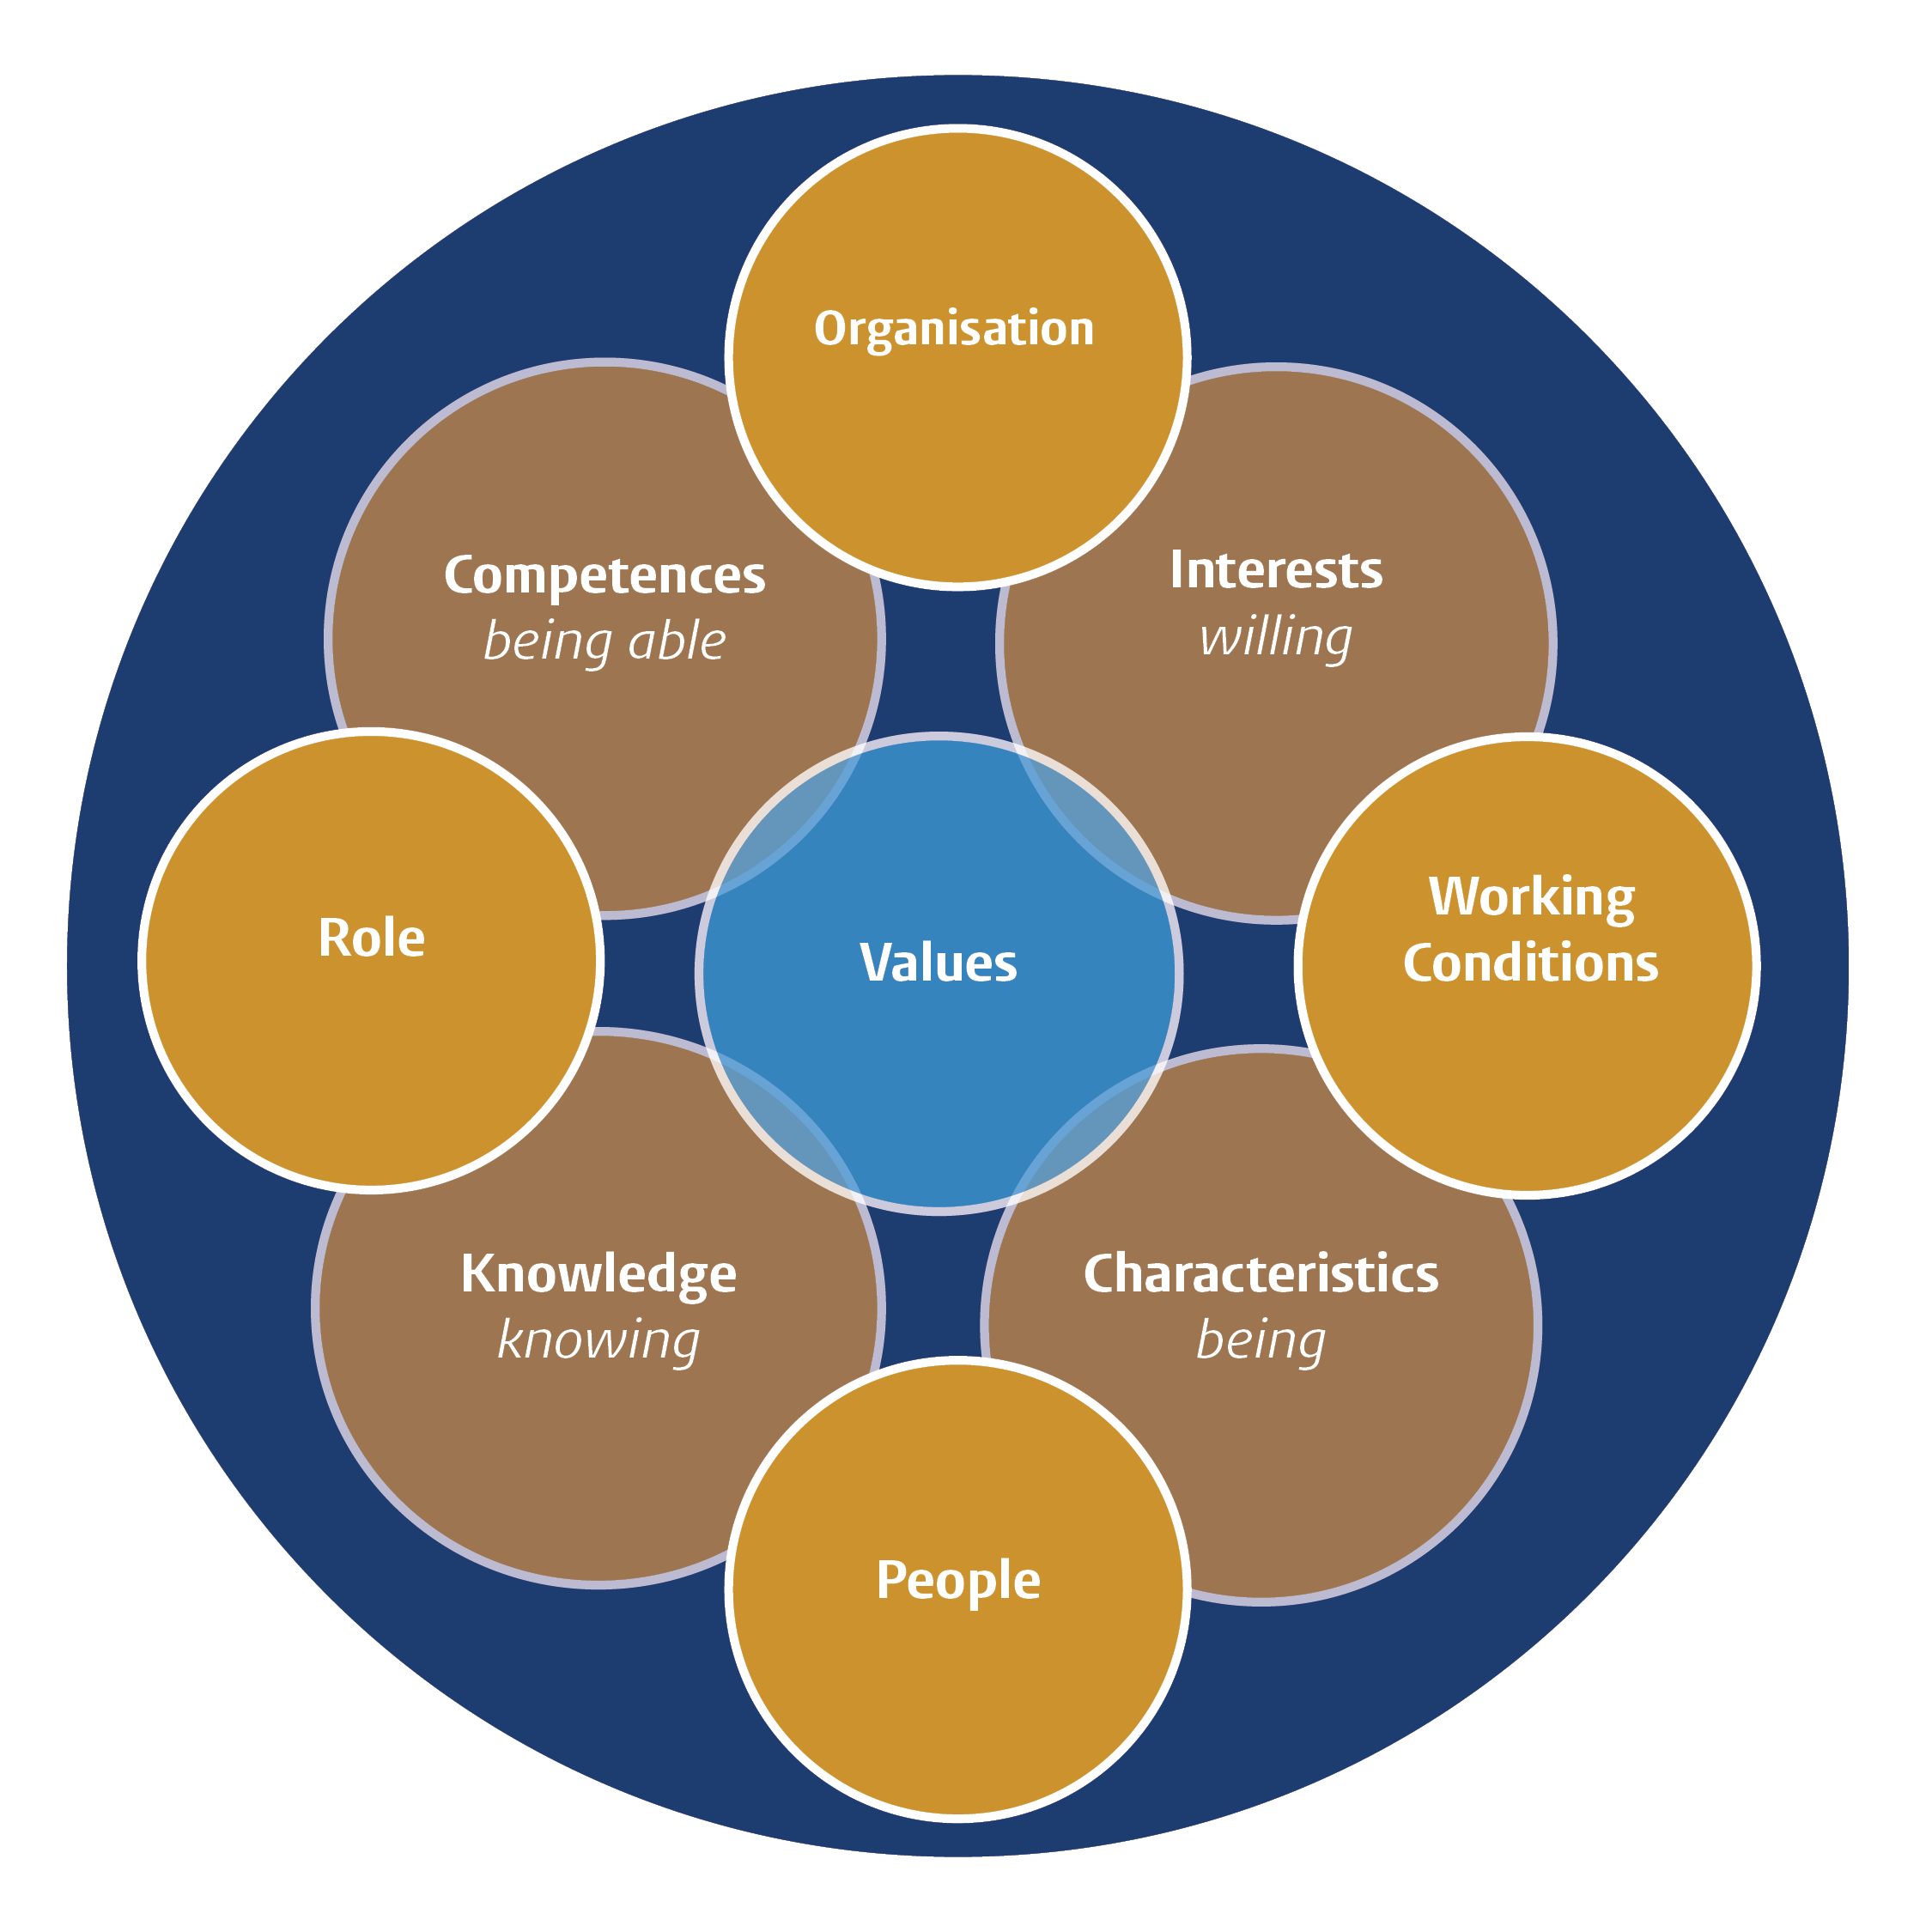

3.1 Personal Career profile
The purpose of this module is to introduce you to the labour market related to your study programme, thereby giving you insight in your own possible career path.
Learning objective of this submodule:
- You have insight in the labour market related to your education;
- You have insight in what type of jobs and sector interest you.
Assignment:
- Read the information on the Career Zone about the labour market and your programme-specific pages.
- What do you already know about your 'own labour market' or specifically a job that would suit you?

- Look for at least three vacancies that appeal to you (think about organisation, tasks, competencies, etc.). Describe what appeals to you and why.
Vacancy 1:

What appeals to me:

Because:

Vacancy 2:

What appeals to me:

Because:

Vacancy 3:

What appeals to me:

Because:

- Look at the information regarding Career prospects on your programme page and also check what kind of jobs alumni of your programme have. You can also find inspiration for yourself in other professions you can think of. Which jobs appeal to you?

- What appeals to you more/less? Specify this in the sections of the Personal Career Profile, so for one job you might be interested in the organisation, the other the sector, and/or the content of the work, and so on.

What appeals to me:

What does not appeal to me (so much):

- You can easily find alumni of Leiden University and your programme via LinkedIn (see also later in this module). Search for three people with an interesting job and take a look at their profile. What exactly do they do and what does their career path look like?

Alumnus 1:

Function:
Organisation:
What is his / her career path:

Alumnus 2:

Function:
Organisation:
What is his / her career path:

Alumnus 3:

Function:
Organisation:
What is his / her career path:

- Based on the above assignments, what can you conclude about what appeals to you more/less?

In the following paragraphs you will pay attention to several components of the Personal Career profile:

3.2 Types of work (role)
The part of the Personal Career profile that deals with types of work, or the "role" is about which activities you find interesting or fun to perform (e.g. presenting, research, teaching). These may be activities that you have experienced within or outside your curriculum.
Learning objectives of this submodule:
- acknowledging what activities you find fun or interesting to engage in (such as teaching, presenting, research);
- recognizing which type of work fields or jobs best suit these activities.
Assignment:
- Which activities do you enjoy or excite your curiosity? You can think of activities directly related to your study programme, such as giving presentations or doing research, or indirectly, such as organizing activities for the study association, but also outside the study, such as playing sports, reading, making music, etc.

- What type of work fields or jobs match those activities? For inspiration you could check out these sites: https://www.prospects.ac.uk/job-profiles / https://www.bls.gov/ooh/

3.3 Type of organisation
The part of the Personal career profile that deals with "type of organisation" is about the background of an organisation that appeals to you, such as local/international, size and commercial/non-profit. You can also think of a sector or working field to which an organisation belongs, e.g. telecom or government.

Learning objectives of this submodule:
- exploring which type of organization you like and why;
- recognizing which type of work fields/sectors or jobs suit you.
Assignment:
- What can you already describe with regard to a type of organisation that appeals to you? Take a look at these branches, for example: https://www.prospects.ac.uk/jobs-and-work-experience/job-sectors or https://www.bls.gov/iag/tgs/iag_index_alpha.htm

- Are there already specific organizations that appeal to you? If so, why these particular organizations? What do they have in common?

Specific organizations:

Why these organizations:

Common characteristics:

3.4 People
The "people" part of the personal career profile is about the people you work with while employed and what type of interactions you experience as pleasant. The list of professionals you engage with may be more extensive than you realize, including amongst others, managers, colleagues, external partners. And your interactions are determined by a large range of factors as well, for instance; the level of formalities involved, the level of education, the degree of freedom and the personal attitudes of the people involved (e.g. ambitious, careful, commercial).
Learning objectives of this submodule:
- acknowledging what you find important in contact with others;
- learning how to optimally function in a team.
Assignment:
- Describe what you find important in your contact with other people? Think for example about experiences in the private sphere, side jobs and studies.

- Can you make out a particular style? In which type of organisations does your style fit best?

Style:

That fits best in:

3.5 Working conditions
The part of the Personal career profile that deals with "terms of employment" (working conditions) deals with all the conditions of employment that one may find important when considering a job, such as salary, training opportunities and commuting time.
Learning objectives of this submodule:
- gaining insight in what terms of employment are important to you.
Assignment:
- Which terms of employment are of importance to you in your search for a suitable job?

3.6 Networking
Another way to gain additional insight into a job or organization and whether this would suit you is by conducting (informative) conversations with people from the professional field. This is the essence of networking.
When one thinks about applying for a job, the first thing that comes to most people’s mind is probably writing a good CV, drawing up an enthusiastic cover letter or perhaps updating one’s LinkedIn profile. These are all very important things to do, but networking can be even more crucial!
Learning objectives of this submodule:
- you know your own network and can expand it;
- you can formulate questions to gather more information on fields of interest.
- you know how to foster contacts both within and outside your network to obtain information on fields of interest.
Assignment:

Networking within your current network
Convinced of the power of networking? Discover your current network and determine your three network action points.
- Choose three people in your current network who (used to) work within one of the fields you are interested in. This can be friends, family, (former) teammates, someone from the sports association, fellow students, someone from the student association, someone from primary school / secondary school, a friend of the family, etc. A good place to start would be looking on LinkedIn, for example, to see who has (had) which internship / (part-time) job.
Three people I would like to approach:

1.

2.

3.

- As a follow-up think of three questions that you would like to ask each person and approach the person for a network conversation. Note: you networking for information, not for a job. You can introduce the questions, for example, by stating that you are currently exploring the labour market and that you are looking for information on a particular field of work/sector.

Questions for person 1:

1.

2.

3.

Questions for person 2:

1.

2.

3.

Questions for person 3:

1.

2.

3.

Expanding my network and networking in my new network
In addition to discovering and using your current network, it is also important to expand your current network. This can be done in various ways, including via the Mentor network and via the alumni database on the company page of Leiden University on LinkedIn.
Take a look at the profiles of mentors on the Mentor network and look for mentors with an interesting and inspiring profile (for you). Who works at an organisation where you would like to do an internship? Who has done an assignment within a sector that has caught your interest?
Then take a look at the alumni database on the company page of Leiden University on LinkedIn, filter on your bachelor/master and look at the profiles of alumni with the same educational background. Which profiles appeal to you?

- Then choose 3 new contacts with whom you will have a network conversation. Think about which questions you would like to ask in advance. And make an appointment with these alumni.

Three people I would like to approach:

1.

2.

3.

3.7 Personal Career profile 2
Make an overview of the most important findings based on the results from Exploring the labour market. By putting the various aspects together, you will create a total overview which, together with the results from Know yourself, form a complete Personal Career profile.

- Fill in the components of the Personal Career Profile (in your working document) for what you can already determine on the basis of the current information and Personal Profile. Put a question mark if you do not yet have an idea of something such as "working conditions" or "role". These are matters to explore further.

My Personal Career profile:

Module Personal Career profile | Description of findings:
Competencies
Career choice / Interests
Characteristics (personality, team roles)
Knowledge (study and other)
Values (work values)
Organisation
Role
People
Working conditions

- Based on your Personal Career profile, describe yourself in one paragraph:

4. STEP 3. DEVELOP YOUR (APPLICATION) SKILLS
Now that you have gained a clearer picture of yourself and the job market, have a clearer idea of which direction you want to go in and what you like, the next step is to (further) develop your application skills.
The information from your Personal Profile and Personal Career Profile forms the starting point for presenting yourself in, for example, your CV, a cover letter or an interview. It helps you to explain your motivation and suitability for a position and to be more confident during an interview.
Part of the assignments in this chapter can be completed in this document. Documents for the other subjects (e.g. CV, cover letters, network schedule) can be saved in your Career Planning folder on your PC.

4.1 Curriculum Vitae
In many cases, it is often the very first thing an employer will see of you: your CV. So it is important to make a good first impression!
A common assumption is that you write a cover letter for each application and that the CV is the same for each application. This is incorrect! The CV must show at a glance why you could be the right candidate for this specific position. Therefore, tailor-made work is of great importance not only for the cover letter, but also for your CV.
Learning objectives of this submodule:
- the ability to draw up a CV, using the information from your personal career profile.
- the insight to tailor your CV towards a specific vacancy.
- the confidence to cast a critical eye at a CV and provide feedback.
Assignment:
- Read the information about Curriculum Vitae carefully.
- Write/update your CV using the tips and examples and use the information from your personal profile and career profile.
- Save your CV(s) in your Career Planning folder.
- Practice matching your CV to specific job vacancies, by mirroring your CV with one of the three vacancies from the assignment of module 3.1:

What requirements are stated in the vacancy?

Does your CV cover these requirements?

What keywords are used in the vacancy to describe what core values they are looking for in an applicant? Mirror these keywords in your CV in such a way that the recruiter / employer will notice at first glance that you could be a suitable candidate. These are the words that need to come back:

1.

2.

3.

4.

5.

5. Let someone else read your CV. What feedback/tips have you received on your CV?

4.2 LinkedIn profile
In the world of job applications, it is impossible to imagine doing without it: LinkedIn. Of course having a LinkedIn profile is not compulsory, but it can bring you a lot of benefits.
A LinkedIn profile is similar to an online resume, which is continuously available. Yet at the same time it is also an online social network focused on the job market where employers and employees / job seekers come together. As such it represents a network platform: through personal connections, groups, and organizations it requires little effort to connect with others. You can look at it as an online business 'address book' complete with background information and contact details of a virtual web of connections. In turn it also functions as a vacancy database where vacancies, internships, projects, volunteer work and opportunities are shared by individuals and organizations through personal networks or in groups. Sometimes it is even possible to apply for a job directly via LinkedIn!
Learning objectives of this submodule:
- Setting up a LinkedIn profile, using the information from your personal career profile.
Assignment:
- Write/update your LinkedIn profile using the information about LinkedIn at the LU Career Zone. Use the information from your CV / personal profile and (career) profile. A well-written CV makes it a lot easier to draw up a LinkedIn profile.
- Write here the url to your LinkedIn profile:
- Present your profile to someone close to you. What feedback/tips have you received on your LinkedIn profile?

4.3 Cover letter
Whether you have found an interesting vacancy or you are applying through a network contact or with an open application, in many cases an application/motivation/cover letter is required.
Learning objectives of this submodule:
- the ability to draw up a cover letter, using the information from your personal career profile and focusing on a specific job vacancy;
- assessing a cover letter, and providing feedback.
Assignment:
- Read the information on the Career Zone about drawing up a cover letter and the information about the vacancy analysis.
- Take a vacancy that you have previously found or look for a vacancy that appeals to you (can also be for a side job, internship, volunteer work, etc.) and study it based on the tips, and highlight or write down the keywords that you consider important for this application.
- Writing is a matter of doing. In this exercise we are not aiming for a perfect result, but for the experience. Based on the vacancy, the analysis and the tips on the website, draw up a plan for your cover letter. So don't pay too much attention to fluent sentences, but rather get to the essence of what you would actually like to convey, having the reader of the organisation in mind. Use the information from your Personal profile and Personal Career profile!
- Save your cover letter(s) in your Career Planning folder.
- Have your letter read by a friend / family member / fellow student. What feedback/tips did you receive on your letter?

4.4 Pitch
One of the questions during a job interview is often 'tell something about yourself'. That's not so easy. One way to do that is by doing a pitch. Pitching is presenting yourself, where you describe yourself briefly but powerfully in 45 to 60 seconds. Writing/making a pitch requires some preparation.
Learning objectives of this submodule:
- the ability to name several of your personal core skills;
- the ability to relate a number of those skills to the requirements in a job vacancy / internship;
- the ability to briefly describe yourself (pitching), including your core skills, in 45-60 seconds;
- the ability to pitch yourself with a certain audience in mind (i.e. for a job vacancy / internship), including their core skills, in 45-60 seconds;
- you can reflect on your own pitch as well as formulate feedback regarding the pitch of other students.
Assignment:

- Write a pitch for the situation you are in right now. This may be a pitch for an internship or a job, but it can also be a pitch in which you focus more on obtaining information as part of your orientation on the labour market/jobs. Use the information from your Personal Profile and your Personal Career Profile for this purpose.

Write your pitch here (also take a look at the summary of your Personal Career Profile 3.7):

- Record the pitch and study it with a critical eye: what stands out to you? What went well and how could you improve pitch?

What is striking?

What went well?

What would I like to improve?

- Practice the pitch with someone you know. What feedback/tips did you get on your pitch?

If you have recorded/filmed your pitch for yourself, save it in your Career Planning folder.

4.5 Job interview
For a successful job interview, good preparation for the interview and practicing an interview are important. You will find that when you are well prepared for a job interview, you will be much more relaxed and perhaps less nervous during the interview itself.

Learning objectives of this submodule:
- learning how to properly prepare for a job interview;
- practicing the STARR interview method.
Assignment:
- Read the information on Job Interview and the related information about the STARR method and Online video interviewing carefully.
- Take a vacancy that you find interesting. This may also be a vacancy that you have previously used in this module. Briefly state your motivation for a job you find interesting. Why are you applying for this position?

- Briefly describe your suitability for the position. Why should they hire you? Also use the information from your application letter, your personal profile and personal career profile.

- Think of three skills (i.e. what are you good at?) that you would like to talk about in an interview. Use the information from your Personal Profile.

Skill 1.

Skill 2.

Skill 3.

- For each of the three skills you have come up with, give a concrete example of a situation in which you have shown that you possess this skill using the STARR method and describe the example.

Skill 1:

S:

T:

A:

R:

R:

Skill 2:

S:

T:

A:

R:

R:

Skill 3:

S:

T:

A:

R:

R:

- Next, practise telling someone else about your three skills (the ones you are good at) using the concrete STARR examples formulated.
- Also practice these questions online (via Teams/Skype) with someone else. Use the tips on applying online.
- What tips or advice did you receive when practicing with others?

4.6 Assessments
An application procedure may include an assessment of the applicant and is aimed at gaining a clear understanding of their knowledge, capabilities, skills, and character traits.
There are various types of assessment (or assessment components), such as personality tests, ability tests, role playing, games and interviews. It is important that you realize you can prepare for these assessments so as not to arrive unprepared!
Learning objectives of this submodule:
- realizing that there are various types of assessment;
- understanding what to expect from the different types of assessments;
- knowing how to prepare for the different types of assessment.
Assignment:

- Read the information on the ‘Career Zone’ concerning assessments.
- Describe in short the different types of assessment, what they entail, and how you can prepare for them.

Personality tests:

Content:

Preparations:

Ability tests:

Content:

Preparation:

Role playing:

Content:

Preparation:

Games:

Content:

Preparation:

Interview:

Content:

Preparation:

- Try a few capability tests (they are a common element in many assessments). For example at LTP. Practice really helps in this case. You let your brain get used to the questions.
- What is your experience with practicing different parts and what else would you like to practise?

4.7 Working conditions
A successful job interview will generally be followed by a second interview covering the terms and conditions of employment which may also include salary negotiations. Here too, preparation is key. This is where your primary and secondary employment conditions are decided and there may be little room to renegotiate at a later stage.
Also look back at your Personal career profile for what you think is important. What have you written down there at Working conditions? It is more than just salary.
Learning objective of this submodule:
- you know what primary and secondary employment conditions are;
- you are aware of which employment conditions you consider important.

Assignment:
- Read the information on the ‘Career Zone’ concerning terms and conditions of employment and negotiation.
- Find three positions that hold your interest and find out what the entry level salary indications are for each. Also look for additional information on the terms and conditions of employment and whether these are covered by a collective labour agreement.

Position / salary indication:
1.

2.

3.

- Find a vacancy that interests you and take the first step: Call the contact person and ask three questions about the vacancy (tip: use the questions you formulated during the interview). Finish with a fourth question: 'May I ask what the salary indication is for this position? What could I expect?’
This is an exciting step, but practice makes perfect! Next time it will be (even) easier.
- How was this for you? What would you do again next time? What would you do differently?
How was this for you?

What would you do again next time?

What would you do differently?

- How could you use this for your negotiating position?

5. STEP 4. FINDING A JOB (VACANCY)
In the previous sections, you gave extensive thought to your personal profile, your wishes on the labour market and how you can best profile yourself. A next step towards the labour market and ultimately a job is the actual search for vacancies.
In order to be able to tackle this properly, it is useful to gain insight into how the labour market, and especially recruitment, works. Therefore, read the information on the Career Zone under 'how to find a job' and 'networking' (possibly studied earlier).

5.1 Networking
During this submodule you will make an inventory of your current contacts to map out your existing network. A good starting point may be the network you created as part of your LinkedIn profile in submodule 4.2. A network can provide a valuable gateway into a career, up to 30% of job searchers find their initial employment by ways of their network.
Learning objectives of this submodule:
- understanding the potential of your personal and professional network;
- knowledge of how to use that network when needed.
- Assess at what stage of your career track you currently are. Are you looking for a job or internship or are you trying to craft professional connections? In either case you are going to learn how to actively market yourself.

- What means or media might be best suitable for making your call public? LinkedIn springs to mind, but you should also consider other forms of social media.
- Share your specific search or wishes (pitch) via e.g. LinkedIn and find out what the power of your current network is. In submodule 4.4 you worked on a pitch; you will now work out the details of that pitch in writing. This is where you choose whether you will focus your pitch on obtaining a job or internship, or whether you will use it in the broader context of gathering information on your orientation or position on the job market.
Your LinkedIn Pitch:

- Make a network schedule for yourself. In a network schedule you display your actions in, for example, an excel file. You note, for example: the date, contact person, company, function, connections, possibilities, contact details, remarks and follow-up actions.
You will find a format for a network schedule on the Career Zone.
Fill in names, potential employers, field of work, etc. and keep track of the status of each network contact. Who did you approach? With which question? Has the person been able to help you further? Do you have to give follow-up/back on this?

5.2 Finding a vacancy (and applying for a job)
Learning objectives of this submodule:
- knowledge of the various channels and routes to job vacancies;
- the ability to send an open application to an employer.
Assignment:
- Search through three channels for vacancies and find at least one interesting vacancy on each channel. Are they worth responding to? Then do so!

Channel 1:

Vacancy:

Channel 2:

Vacancy:

Channel 3

Vacancy:

Find an organisation where you would like to work and perhaps even with an ideal job in mind. Do you dare to make an open application? To do this, follow the steps in module 4.3, first have your cover letter read by a fellow student/friends/family and then send it in!

Organisation where you are going to apply:

Because:

5.3 Recruitment
In addition to being in paid employment with an employer, there are other ways to get a job, such as self-employment but also through an employment agency.
Find out more about temping, secondment and recruitment & selection via the Career Zone.
Learning objectives of this submodule:
- you have gained more insight in the different kinds of employment agencies.
Assignment:
- Research online which employment agencies are active in the field you are interested in. Take a look at their websites, read about their working methods and view their current vacancies.

Agencies found:

1.

2.

3.

4.

- Is there a possibility to make an open application? Apply immediately or put it on your to-do-list for later.

6. TRANSITION TO LABOUR MARKET

6.1 Transition period
After all these years of hard studying, many students are looking forward to the next phase in their lives. Still, you can have mixed feelings about this period. You may be happy and proud to have your diploma in your pocket, but at the same time you may find it a difficult period. Everything is going to be different from now on. The transition to this new phase in your life is therefore not easy for everyone.
Assignment:
- You can read information on this transitional phase on the Career Zone.

6.2 First job
Your first job after graduation is probably not the first job you've had, but it might feel like your first 'real' job. Of course you want to make a good start and it might be useful to know what to take into account. What do you do on your first day at work, the first work period, how do you start a new job in corona time and how do you communicate on the workplace?
- Your first working weeks
- A new job in corona time
- Communicating in the workplace
Assignment:
- The above tools and tips will certainly help you to make a pleasant start in your new job.
So read the information carefully.

7. COMPLETING CAREER PLANNING MODULE
You have now completed the Career Planning step-by-step plan. If all went well, you now have a clearer picture of yourself and your wishes regarding the job market, you have developed job application skills and you have been given tools to find a job.

7.1 Action plan
With all this information you probably have a clear idea of which direction you would like to go, what kind of job and in what kind of organization. Or you know what you still need to be able to make a good decision. Above all, it is advisable to draw up an action plan to actually carry out your plan.
Assignment:
- Formulate an action plan for your intended goal. Indicate each specific action, and specify when and with whom, etc. (formulated as SMART as possible). Make sure to keep your plans realistic and feasible but above all as concrete as possible. Ask yourself the following questions: what information do I still need? How am I going to acquire it? Who haven’t I called / spoken to / emailed yet? And when am I planning to do so?
Whether you choose to work in the Career Planning ‘working document’ directly, or in a separate document is up to you.

- Discuss your action plan with a fellow student. Ask for feedback and suggestions. Is it attainable? Are there any more actions you need to perform?
What tips have you received?

Action | When? | With whom? | …………

7.2 Career pitch
At the end of this step-by-step plan, it is useful to use your findings in your Personal and Personal Career Profile to make a Career Pitch. This pitch is focused on the situation you are in right now. This can be a pitch for finding an internship or an entry-level job, but it can also be a pitch that is more generally aimed at obtaining information in the context of your orientation on the job market.
Assignment:
- If not done so already, complete your Personal career profile. Write a Career Pitch (use the information from your ‘working document’ in combination with the suggestions on pitching from submodule 4.4 and your own information from submodule 5.1).

Practice and present your pitch to fellow students (for example in the context of your study programme / tutoring) / friends / family members.
Tips I have received:

